Flowchast

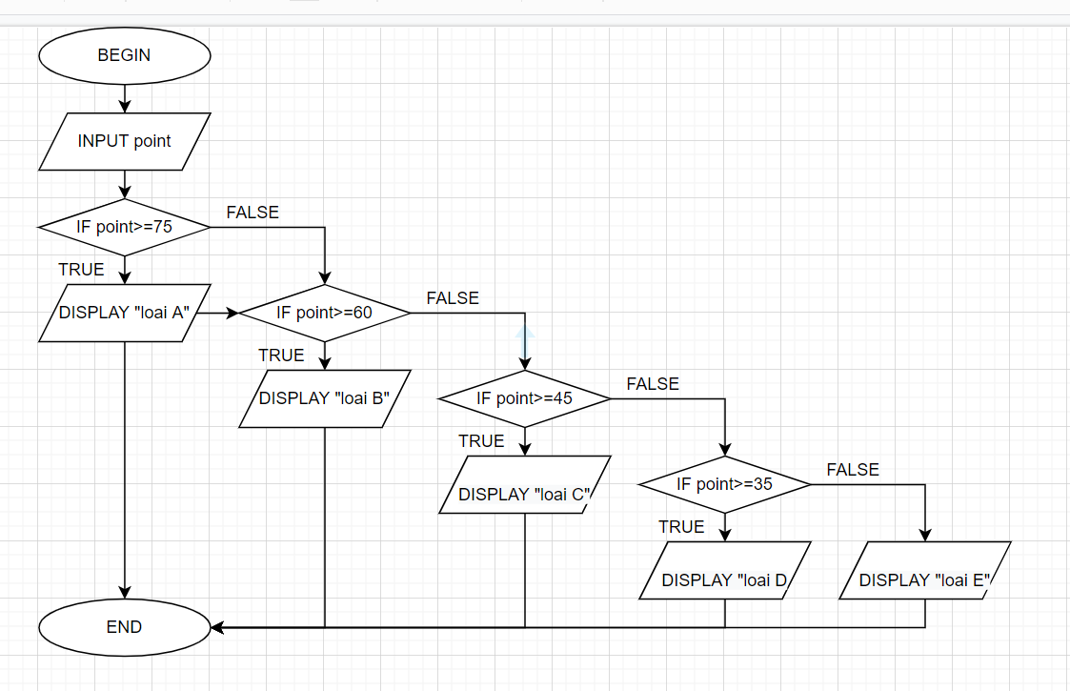

Pausedo-code:

BEGIN

INPUT point;

IF(point>=75) {

DISPLAY “Loai A”;

IF(point>=60) {

DISPLAY”Loai B”;

IF(point>=45) {

DISPLAY “Loai C”;

IF(point>=35) {

DISPLAY “Loai D”;

ELSE

DISPLAY “Loai E”;

}

}

}

END